(Approx. 1589 words)

President’s Corner
What happens when your Zoom host has a power outage – and other happy tales
By Greg Skalka, President, Under the Computer Hood User Group
August 2020 issue, Drive Light
www.uchug.org
president (at) uchug.org

In these COVID times, large gatherings are prohibited, so groups like ours can no longer meet in person. Fortunately, technology has come to our rescue, as many groups now hold virtual meetings through Zoom or another video conferencing service. As was made clear to me at our last meeting, however, technology runs on electricity, and you can’t participate when your power goes out. Several factors played in our favor, so for most attendees, the show went on without me with many probably unaware. As long as the outage is not too widespread and the meeting is set up correctly, we found Zoom is very robust and fault-tolerant, even when the meeting host drops off.

Our last physical meeting was in the first week of March, just before our meeting venue was closed to outside groups. Since then, we have met in the cloud on Zoom quite successfully. A large part of that was due to APCUG (Association of Personal Computer User Groups), of which our group is a member. APCUG has provided us access to one of their paid Zoom accounts, so our meetings can run their normal two-hour duration (avoiding the time limits of a free account). Additionally, our board meets once a month using Zoom. For three of our four Zoom general meetings, APCUG also provided us with presentations through their Speakers Bureau presenters. We are now so used to the virtual meeting format that it has become routine. That is often when fate decides it is time to throw a curveball.

Our July meeting initially followed our now-familiar script. I had scheduled our meeting using the APCUG Zoom account and sent the meeting information to our editor, Art, so that it could be sent out through the member email list. Thirty minutes before the meeting start time, I logged into Zoom and started the meeting session.

While we so far have not had any of the virtual meeting problems other non-APCUG groups have reported (like Zoom-bombing), we try to follow all recommended security precautions. We now use a passcode for our meetings to reduce the chance of random interlopers. We have also enabled the Zoom waiting room, which keeps those joining in a virtual holding area until admitted to the meeting by the meeting host. We don’t publish our meeting’s Zoom information, but instead, send it only to our members, vetted guests, and those that have requested it through email (and have provided a name so that they can be recognized in the waiting room).

To help me in this waiting room filtering, our editor tries to come into the meeting early. I make him a co-host, giving him the power to see and admit from the waiting room (and, as it turns out, take over should something happen to me, the host). In those 30 minutes before the meeting, I also share my screen periodically, showing a few presentation slides with basic meeting information for the evening, so attendees know they are in the right place and know what to expect.

At about 7 PM I started our July meeting with an introduction of the evening’s agenda. Following tradition, I then made our Webmaster, Bob, a co-host, so that he could share his screen and show us the links to new, exciting and helpful software he had added this month to the Library Links section of our web site (www.uchug.org).

Following Bob’s report, I introduced our APCUG Speakers Bureau presenter for the evening, Francis Chao, and made him a Zoom co-host. Francis then shared his screen for the first of his two presentations, a comparison of cloud storage services. I’m not that enamored with cloud storage, so I was waiting for his second presentation (which I had suggested to the board), USB-C.

Francis was probably about halfway through his interesting USB-C presentation (around 8:15 PM) when I suddenly heard the sickening sound of a power outage. Some might say that a power outage makes no sound, that it is more an absence of sound, but I disagree. The clicks of relays switching off, the change in pitch of computer fans slowing down and the frequency of power supply hum changing all make up the sound I recognize as power failure. Even before my eyes could tell my brain about the sudden loss of photons, it knew from the sound what had happened.

Since the desktop PC, I was Zooming on did not have a UPS or uninterruptable power supply, I sat there in the dark for a moment, wondering how widespread the outage was. Though it was past sunset, I could see by the dim outside glow enough to get up and out of the upstairs computer room. I saw through the front windows that my street was dark and neighbor kids were starting to come outside with flashlights.

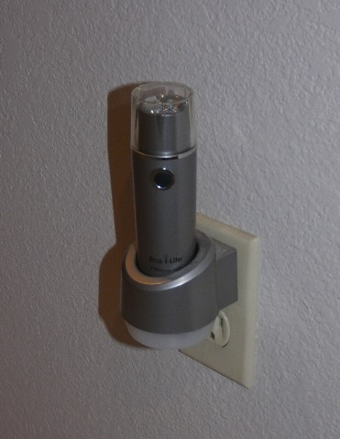
My first concern was for the safety of the first lady. I found my wife downstairs in her office, on her computer. She has a practically brand-new desktop PC with dual monitors and a UPS with a brand-new battery. I had replaced everything for her at the beginning of the year in response to that now insignificant crisis, the Windows 7 end-of-life. She sat in the glow of the monitors. I told her to save and close everything, and then shut her computer down.

The next course of action was to get flashlights. We have a handy rechargeable flashlight plugged into an outlet in our downstairs hall. The flashlight part sits in a charging base, so it is always ready. The light comes when it loses its input power (either from being lifted out of its base or by an outage). When the power went off, the flashlight came on like a beacon. I took the flashlight out of the holder and proceeded to the garage, where our emergency flashlights were stored with our camping gear.

Going into the garage, I instinctively flipped on the light switch, and then realized that was a pointless action. I would find myself doing the same thing several more times before the power came back. I got to the camping gear and found the flashlights, but they were all dead. “Time to buy more 6V lantern batteries,” I told myself. I took my rechargeable auto trouble light from the garage and went back to the house.

It was finally time to send a text to Art to tell him my street’s power was out. Was the Zoom meeting still going? He replied that it continued without me. Having others as co-hosts allowed Zoom to handle my dropping out and continue with the meeting. Likely, most attendees didn’t even notice.

I next went around the house looking for things that should be turned off, so surges, when power is restored, won’t cause additional damage. I turned off the PC I had been using for the Zoom meeting. My laptop was on as it has a built-in UPS, its battery. Not sure how long the power would be off, I shut it down. I also have an old XP desktop in my home office that now was quiet. It normally is always on, except during a power outage. The automated call we received from SDG&E indicated the power was estimated to be restored by 2:30 AM. I went around the house turning off light switches, in case it did come back on after we had gone to bed.

Around 9:30 PM the power came back on. I sent Art another text; he said the meeting had ended about 30 minutes earlier. The meeting had worked out fine despite my being powerless.

Next came the most annoying part of a power outage – resetting the many clocks that have no power backup. I also had to wait for the modem and router to come back up, for my Wi-Fi mesh router to restart and for all my Wi-Fi devices to reconnect. Since I’d need my desktop PC working in the morning to take my online health assessment so I could go into work in these COVID times, I had to verify it would boot up. I tried turning on my XP computer, but it would not show any signs of life. The last time I had shut it off I had problems getting it to start again. At the time, I thought the power supply has a problem but managed to get it running. Now I left its diagnosis for another time.

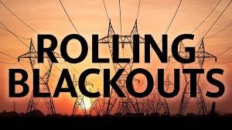
It turns out this outage was just a warm-up (pun intended) for another one we had about a week later. An excessive heatwave in the west meant the possibility of rolling blackouts instituted by the utility company. We had our power shut down for about 30 minutes, but this time it was around dinner time and still light outside. I’d at least learned my flashlight lesson and bought some lantern batteries a few days before.

With our hottest days in San Diego probably still ahead this year, we should count on losing power again soon. Whether due to rolling black-outs to reduce stress on the power grid or shut-downs to reduce wildfire risk, any of us could have that powerless feeling in our future. Now is time to prepare – stock up on batteries, get those UPS units working and back up and save your computer work often.

